|  |  |  |  |
| --- | --- | --- | --- |
| 光電實驗一預報 | | | |
| **組別：**第八組 | **系級：**電機三 | **學號：**B07901042 | **姓名：**趙少緯 |

1. **實驗名稱**

Laser Experiment

1. **實驗目的**

To understand the longitudinal modes of a He-Ne Laser.

To understand the principle of a confocal scanning Fabry Perot interferometer spectrum analyzer.

To understand the transverse modes of a He-Ne Laser.

1. **實驗架構**

Observe longitudinal modes using He-Ne laser.

1. **實驗步驟**

Block beam path

Plug in the laser

Turn on the laser

Verify laser operation

Conduct operating check

Laser power measurements

Longitudinal mode measurements

Transverse mode measurements

Turn off the laser

1. **預報問題**
   1. **A cavity made of two flat mirrors (of 5 cm diameter spaced 10 cm apart) have been misaligned. One of the mirrors have a $1°$ tilt. What is the maximum number of reflections within the cavity before the light escapes the cavity completely? (State the assumptions you made with your answer, and show your reasons.)**

Assumption:

The mirrors are placed $10cm$ in between, then rotate $0.5°$ each.

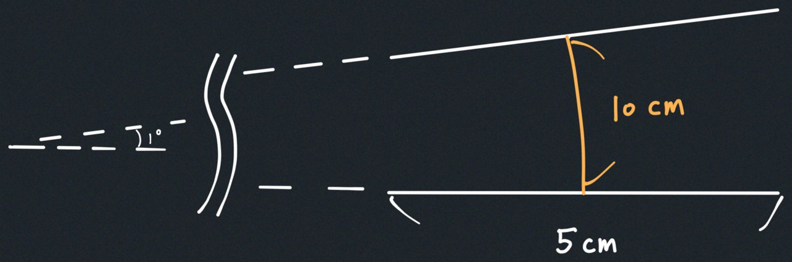

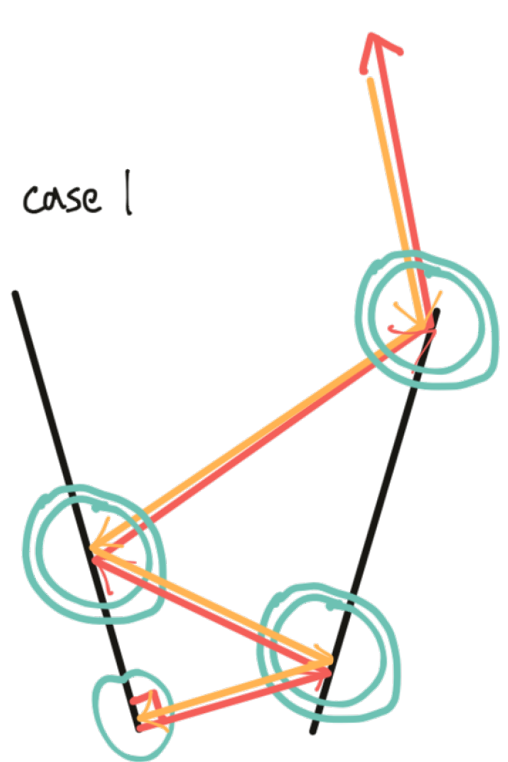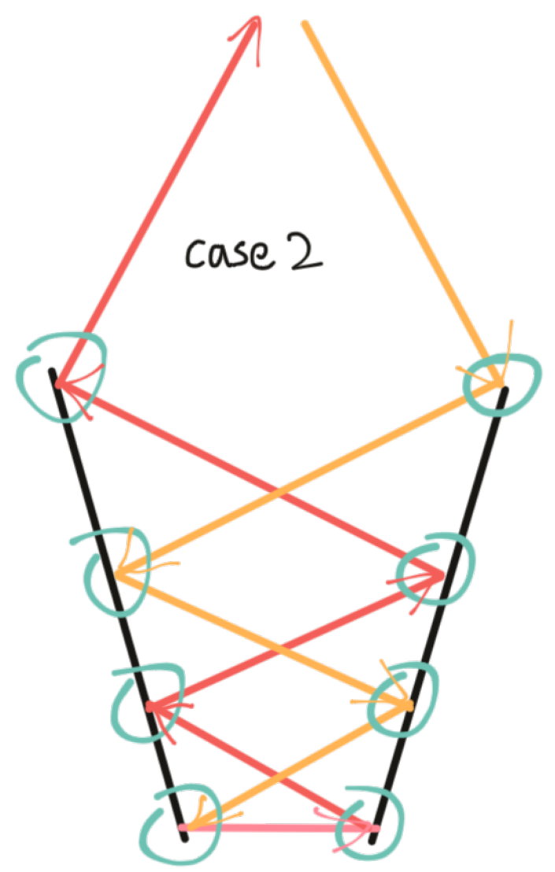

**Case 1**, There will have a light ray shooting perpendicularly to one of the mirrors. We can simplify our problem to this graph, and see how many degrees the light ray will span across the circle.

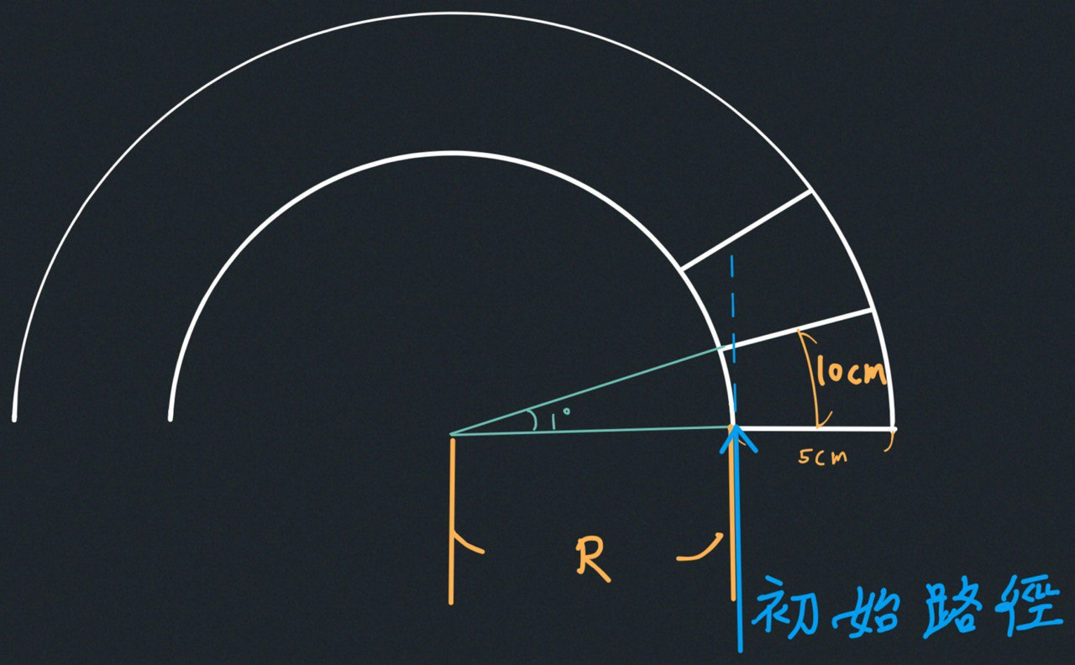

The $R$ value can be estimated by

$$10cm≈\left(R+2.5cm\right)×\frac{1°}{180°}π$$

So $R≈570cm$.

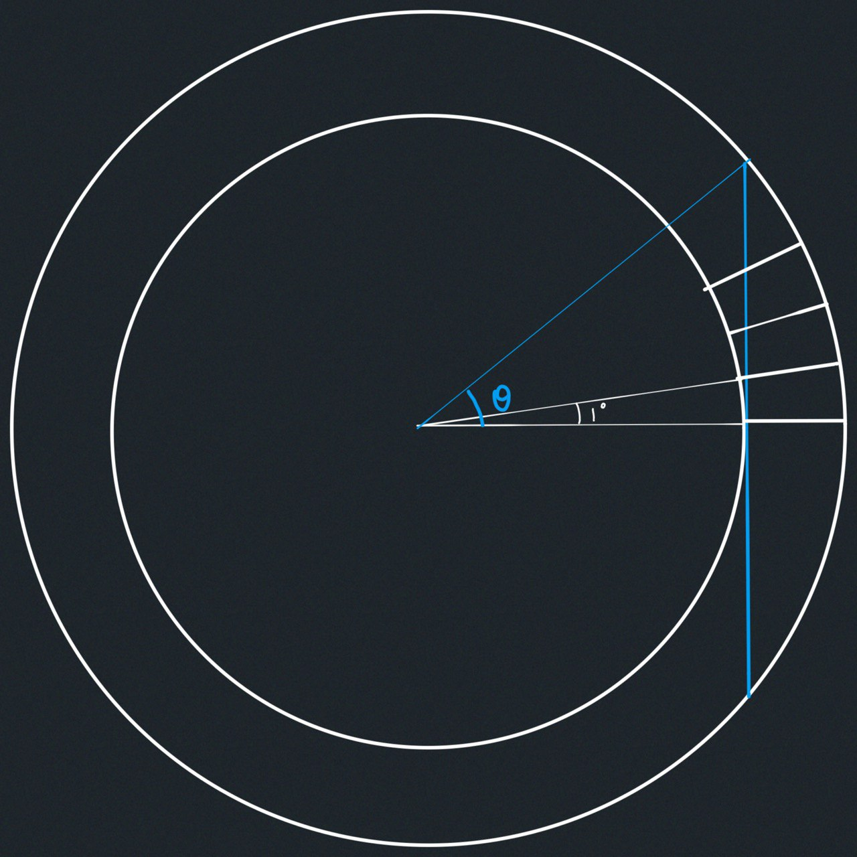

$$\#=2\left\lfloor \frac{θ}{1°}\right\rfloor +1=2\left\lfloor \frac{\cos^{-1}{\frac{R}{R+5cm}}}{1°}\right\rfloor +1=2\left\lfloor 7.56…°\right\rfloor +1=15$$

Case 2, The $R$ value are the same as case 1.

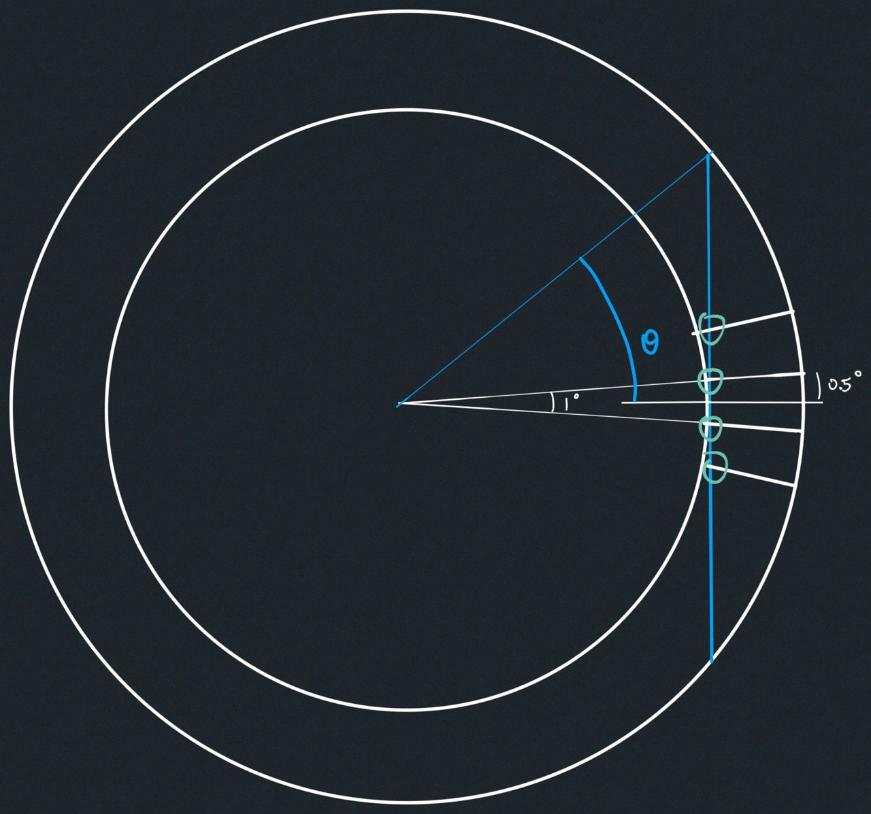

$$\#=2\left\lfloor \frac{θ+0.5°}{1°}\right\rfloor =2\left\lfloor \frac{\cos^{-1}{\frac{R}{R+5cm}}+0.5°}{1°}\right\rfloor =2\left\lfloor 8.06…°\right\rfloor =16$$

Therefore, the maximum number of reflections is **16** reflections.

* 1. **Draw the transverse mode (Hermite-Gaussian) intensity pattern of TEM 01, TEM 10, and TEM 01+TEM 10.**

Hermite-Gaussian modes are solved with a square boundary. The patterns are as following.

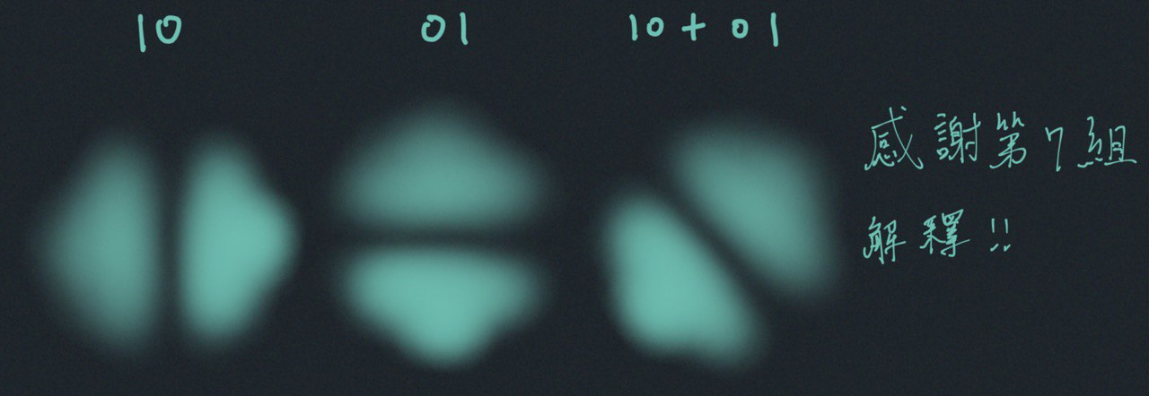

* 1. **A cavity is made up of two mirrors, spaced 100 mm apart. Calculate the wavelength and frequency of the (longitudinal) fundamental mode and 2 other modes of the cavity.**

Since $100mm=λ_{0}/2$, the fundamental wavelength $λ_{0}=200mm$

Assume that the speed of light in this cavity is approximately the speed in the vacuum, which is $c_{0}=3×{10}^{8} (m/s)$

Using $c=ν×λ$, we get that the fundamental frequency is $ν_{0}=1.5GHz$

And 2 other modes of the cavity are

|  |  |  |
| --- | --- | --- |
|  | Wavelength | Frequency |
| Fundamental | $$λ_{0}=200mm$$ | $$ν_{0}=1.5GHz$$ |
| First | $$λ_{1}=100mm$$ | $$ν_{1}=3GHz$$ |
| Second |  |  |

* 1. **A crystal with refractive index n=1.6 is placed inside the cavity between the two mirrors. How will this affect the wavelength and frequency of the cavity modes?**

Since the overall distance remains the same, the wavelengths of the cavity modes won’t change.

However, because $c=ν×λ$, and the speed of light in the cavity is only $1/1.6$ compared to in vacuum, thus while the wavelengths remain the same, the frequencies will be multiplied by $1/1.6$.